Factors affecting demand for breakfast cereals
Over recent years, many factors have affected the UK market for breakfast cereals. The single most important is probably health – or the perception of health. Between 2007 and 2012 the market grew £200million by value – with almost all the gains going to existing and new brands perceived to be healthy. In 2007 Kellogg’s Special K’s focus on dieters made it seem healthy. In 2012 Weetabix, oat-based products and mueslis such as Alpen had the winning formula.
A second influence was the decision by the last government, in 2008, to prevent cereal producers from advertising children’s brands in children’s TV slots. This had little immediate effect on sales, but slowly it seems to have hurt brands such as Sugar Puffs and Frosties. (For info, ‘healthy’ Alpen has more calories per 100gm than Frosties, but marketing is about perceptions, not realities.) Despite the general strengths of ‘healthy’ cereals, Kellogg’s has achieved success with Krave - a chocolate-based, indulgent cereal supposedly aimed at young men.
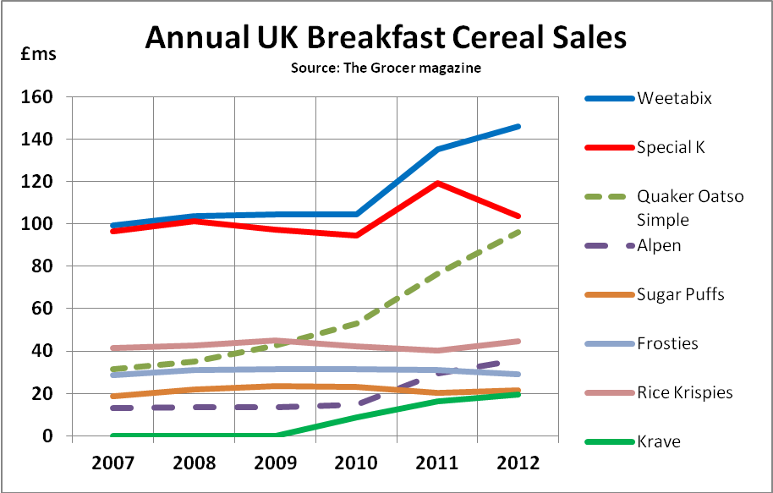
One other factor has been hugely important to this market – the continuing move away from sit-down breakfasts towards breakfasts on-the-go. In some ways the producers can capture this change through cereal bars, but once out of the house, school children in particular may end up buying crisps and an energy drink rather than cereal. In 2012 the market grew 3.9% by value, but fell 1.4% by volume.
The final issue has been the recession. This has hit manufacturers in two ways: first, it has forced them to fight harder with promotional pricing, thereby lowering profit margins. In 2012 half of all breakfast cereal was bought on special offer. Second, and at least as important, there has been a switch to supermarket own-label cereals. In 2007 18.9% of sales were supermarket brands. By 2012 this figure had risen 20.9%.
The table below shows the actual UK sales figures recorded each year by The Grocer magazine. Weetabix and Special K are the number 1 and 2 brands.
Figs in £ms* | 2007 | 2008 | 2009 | 2010 | 2011 | 2012
Weetabix | 99.3 | 103.7 | 104.6 | 104.4 | 135.1 | 145.8
Special K | 96.5 | 101.2 | 97.4 | 94.6 | 119.4 | 103.5
Quaker Oatso Simple | 31.5 | 35.2 | 42.7 | 53.1 | 76.7 | 95.9
Alpen | 13.2 | 13.5 | 13.6 | 14.5 | 29.6 | 36.0
Cornflakes | 63.7 | 65.2 | 66.9 | 66.7 | 63.4 | 64.7
Sugar Puffs | 18.6 | 21.7 | 23.4 | 22.9 | 20.3 | 21.4
Frosties | 28.6 | 31 | 31.3 | 31.4 | 30.9 | 29.0
Rice Krispies | 41.6 | 42.6 | 44.9 | 42.4 | 40.1 | 44.8
Krave | 0 | 0 | 0 | 8.5 | 16.1 | 19.5
Total market | 1,334.80 | 1,378.10 | 1,458.30 | 1,465 | 1,451 | 1,532.10
*The figures are in current prices, i.e. they are not inflation-adjusted

Questions (30 marks; 35 minutes)

1. Following a decline in its sales in 2009 and 2010, Special K had a great year in 2011. Outline two factors that may have caused this. (4)

2. Examine two factors that may have affected the demand for Alpen between 2007 and 2012. (8)

3a) Calculate the market share for Frosties (to 2 d.p.) in 2007 and again for 2012. (3)
3b) Briefly explain why this information might be important to Kellogg’s, owners of the brand. (3)

4. From the information provided and your wider knowledge, evaluate two factors that might affect the total market size for cereals over the coming 12 months. (12)
ANSWERS and MARKING GUIDANCE

1. Following a decline in its sales in 2009 and 2010, Special K had a great year in 2011. Outline two factors that may have caused this. (4)
Marking scheme: up to 2 for relevant points; up to 2 for application
- Kelloggs may have introduced an extension strategy to halt the brand’s decline, e.g. a new, best ever taste, or a new brand variant, e.g. Special K Superfruits; the evidence in the data is that this failed to have a sales follow-through in 2012
- Or they may simply have put a lot of promotional budget behind the brand that year: more TV advertising, more on-pack competitions and more aggressive promotional pricing; again, the 2012 sales decline will have been a disappointment, though sales are still significantly higher than in 2010

2. Examine two factors that may have affected the demand for Alpen between 2007 and 2012. (8)
Marking scheme: up to 2 for relevant knowledge; up to 2 for application; up to 4 for analysis
- The causal factors are clearly longer term than in the case of Special K; this implies a trend rather than a temporary factor; the most obvious trend is consumers’ greater conviction that muesli-style cereals are healthier than Kelloggs’ highly-processed types of cereal; this is also reflected in the performance of Quaker OatsoSimple
- Another possible factor is that Alpen’s owner may have decided to give it more marketing support; this might mean a push across the marketing mix, i.e. a new, bolder approach to price, promotion and distribution (place), maybe backed by a reformulation of the product

3a) Calculate the market share for Frosties (to 2 d.p.) in 2007 and again for 2012. (3)
3b) Briefly explain why this information might be important to Kellogg’s, owners of the brand. (3)
3a) 2007: £28.6m/£1,334.8m x 100 = 2.14% 2012: £29m/£1,532.1m x 100 = 1.89%
3b) To Kellogg’s the fall of 0.25% is important. Not only is it worth £3.8m of sales (£1,532m x 0.25%), but it also might suggest a continuing fall in the future

4. From the information provided and your wider knowledge, evaluate two factors that might affect the total market size for cereals over the coming 12 months. (12)
Marking scheme: up to 2 for relevant knowledge; up to 3 for application; up to 3 for analysis; up to 4 for evaluation
Possible lines of answer:
- In any market it is hard to identify which factors are the most important in determining demand. It does look as if the recent recession hit the market for cereals in 2010 and 2011 (as 2011 sales were lower than in 2009 in money terms). Nevertheless other factors may have been equally important, such as the banning of TV advertising in kids’ TV programmes. Overall, though, my bet is that the economy will have a reasonably good next 12 months, allowing the breakfast cereal market size to rise by perhaps 2 – 4%.

- Another key factor is the trend in health-related consumer tastes and attitudes; this is very unpredictable; in the past a trend for low-carb diets has hit sales hard for brands such as Cornflakes, causing a decline in the market size; I’m going to assume, though, that consumers in recovering-from-recession mode will not be too faddy, allowing the market size to grow – as mentioned, by 2-4%

- Which of these factors is the more important? I suspect that the economic factor will be more important this year, as families start to recover from the shock of recession

