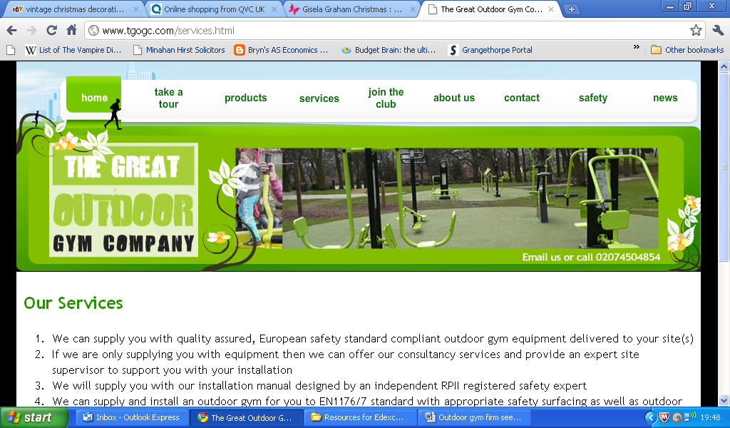

Outdoor gym firm sees healthy profits

One of the great debates of our time is how to improve the state of the nation's health, and it was this challenge that provided the inspiration for The Great Outdoor Gym Company.

Three years ago the company's founders, Matt Delaney and his fiancée, Georgie Tarrant, were working for Sport England when they learnt from a delegation from the Beijing Sports Bureau that the Chinese government was installing millions of square feet of outdoor gym equipment to provide free facilities for people to use in parks and public spaces.

Inspired by the Chinese model and reasoning that two of the main barriers to people improving their fitness were cost and access, the couple decided that such free and widely available facilities were a phenomenon waiting to happen. So convinced were they that this was a great idea that Ms Tarrant left her job with Sport England to start the wheels of their new company turning.

"She effectively was a one-woman cottage industry, working from one room in our house, trying to develop leads, sell this totally new concept and research equipment that would meet the required safety standards," explains Mr Delaney.

The pair poured every penny they could spare, including an inheritance from Ms Tarrant's grandmother, into the business and soon Mr Delaney decided it was time for him, too, to make a full-time commitment. He was joined, part-time, by
Ms Tarrant's father, and the three of them worked flat out to get the concept off the ground, doing everything from sales to product design.

"Georgie and I are both very driven people anyway," says Mr Delaney, "but when you put everything on the line it makes you even more hungry."

Eighteen months after they set up the business, they got a call from a senior police officer in the Strathclyde force. He wanted to install a gym on a piece of scrubland on a housing estate that was a notorious flashpoint for opposing gangs. He believed that by involving teenagers in a non-confrontational, healthy lifestyle he could reduce street violence. A subsequent report has cited the outdoor gym as one of the measures that have resulted in an 8% reduction in local crime.

In their first year of what Mr Delaney calls "proper trading", they sold three gyms but it soon became clear that they could not reach the volumes they believed were possible if they continued to work as they had been. "We realised that if we kept this model going, with us doing everything, we would be burned out before we knew it."

So they took a long, hard look at their business and decided to change the way they worked – instead of selling direct they would sell through partners who were already working in a similar marketplace, such as playground suppliers and companies selling into schools. It was a move that would transform the business. "We formed partnerships with four or five fairly big organisations that had the infrastructure to allow us to grow really fast."

Another key partnership has been with sports equipment manufacturer, Adidas, a sponsor of the 2012 Olympics. Since 2008, The Great Outdoor Gym Company has worked with Adidas to deliver the nationwide "adiZone" programme e_SEnD youth-focused multi-purpose outdoor fitness facilities in the shape of the 2012 logo. Four adiZones were piloted in the host Olympic London boroughs with such success that Partnerships for Schools is now working with Adidas to fund 40 further sites across the country.

As the business has grown, six more family members have joined, bringing a wide range of skills, while three further staff have brought in experience in graphic design, gym installation and IT support.

With distributor agreements in Holland, Dubai and Italy, the business is on track for turnover of £2.3m this year and has what Mr Tarrant believes is a very realistic target of between £5m and £6m next year. The Great Outdoor Gym is coming to a park near you, very soon.

(Source: www.telegraph.co.uk By Jenny Hirschkorn, 20 Feb 2010)

Questions:

- Briefly explain what motivates individuals such as Georgie Tarrant to give up a well paid job to run their own business.

- Briefly explain which sources of finance might have been available to Matt Delany and Georgie Tarrant for The Great Outdoors Gym Company.

- For each of these sources of finance, identify the advantages and disadvantages of using this finance for their business.

- Why do you think they decided to form a limited company rather than operate as a partnership?

- What are the advantages and disadvantages of forming partnerships with larger businesses such as Adidas?

- Do you think it is a good idea to employ family members in a business? Why?

- Explain which economic factors will affect The Great Outdoors Gym Company.

Mark Scheme

- Entrepreneurial motives could include making a profit/earning more income in the long term and non-profit motives such as being your own boss and job satisfaction. The evidence also states that the company did provide equipment for Strathclyde police which resulted in a 8% fall in crime so could be argued that one of the motives was a social purpose in terms of healthy living, crime reduction.

- A variety of sources were available and have been quoted in the evidence, such as bank loan, personal savings (inheritance), family/friends as well as using short term finance such as trade credit.

- For each of these sources of finance look for one advantage and one disadvantage. Students can consider interest rates, cost, ease of acquiring the finance, amount available, risk.

- Limited liability is the main reason why a business would become a company. Other considerations might include protection of name, separate legal identity, continuity of business and easier access to new investors.

- Advantages could include support from a much larger and well established company who has access to marketing and R&D support therefore shared risk. Brand recognition and appeals to target market. Disadvantages may include shared profit, lack of power in the agreement and culture clashes.

- No real correct answer! May lead to conflicts of interest and can be difficult to discipline family members but may also mean control is kept within the family and there may be more trust than employing outside employees. Could mention the recent newspaper articles about Gordon Ramsey and his family issues!

- Wide range including interest rates (monetary policy), government spending and taxation (fiscal policy), business/consumer confidence, inflation, exchange rates and economic growth. Try and get students to explain how these affect a business such as the The Great Outdoors Gym Company - maybe bring in PED and YED if covered in Unit 2b.

