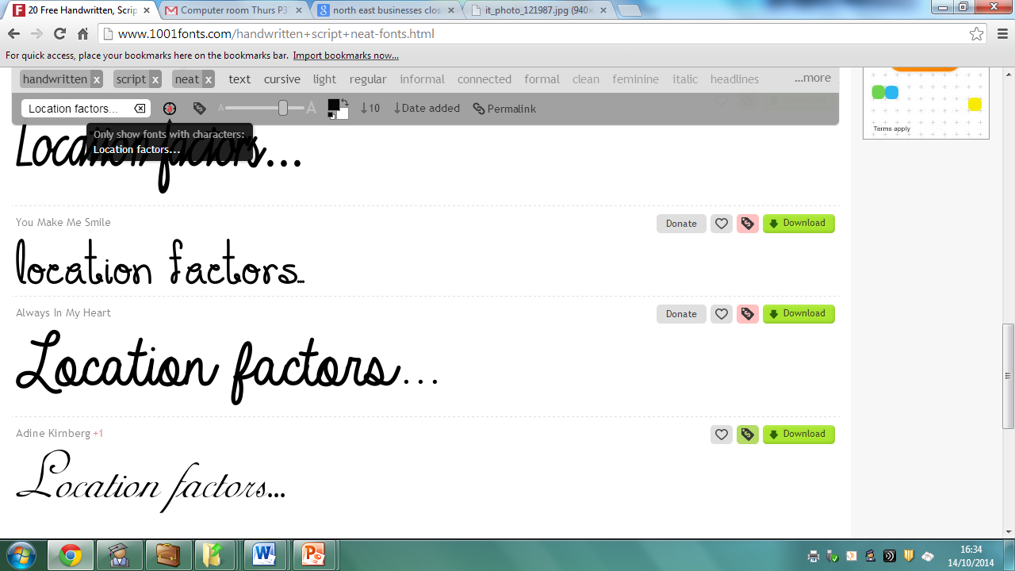**The location of businesses is influenced by a number of main factors:**

|  |  |
| --- | --- |
| **The location of raw materials**  This means that raw materials are located nearby. This can reduce the costs of transportation. | http://www.malabaribusiness.com/wp-content/uploads/2011/05/raw_materials-copy1.jpg |

|  |  |
| --- | --- |
| **The supply of labour**  This is where a business locates to an area where there are many potential employees with the necessary skills for the jobs they have, or areas of high unemployment making employees easy to find. | http://www.dreamaustralia.com.au/assets/Uploads/Immigration-Advice/_resampled/ResizedImage401262-everyday-workers.jpg |

|  |  |
| --- | --- |
| **Transportation links**  This could mean a business locating near a sea port to import or export resources. This could be where there is good road or rail links to transport goods. | http://www.essexhighways.org/uploads/images/schemes_and_projects.jpg |

|  |  |
| --- | --- |
| **Cost of Premises**  Some business may locate where rent or land is cheap to buy or taxes or low. They will also take into consideration greenfield and brownfield sites. | http://thumbs.dreamstime.com/z/social-network-mobilie-communication-concept-26028651.jpg |

|  |  |
| --- | --- |
| **Proximity to market (close to customers)**  This is where businesses need to be close to their customers in order to be successful. This could also be somewhere with high footfall, or customer numbers | http://www.webroot.com/shared/images/current-customers-people.png |

|  |  |
| --- | --- |
| **Climate**  Where a specific type of weather or climate is needed for a business | http://upload.wikimedia.org/wikipedia/commons/a/a9/Projected_impact_of_climate_change_on_agricultural_yields_by_the_2080s,_compared_to_2003_levels_(Cline,_2007).png |

|  |  |
| --- | --- |
| **Government subsidies**  Governments may pay large businesses to locate in a specific area; this could be to reduce high unemployment with tax breaks for businesses in return. | http://static.itpro.co.uk/sites/itpro/files/styles/gallery_wide/public/images/dir_243/it_photo_121987.jpg?itok=FKclYIKl |