Galaxy Chocolate at 15p. Head for India.
Around the globe, the $100bn chocolate market is a battle between three multinationals: Mars, Nestle and Mondelez (the Kraft subsidiary that includes Cadbury). An exception is India, where Mars has no significant foothold. Given that India is the world’s fastest-growing market for chocolate, it should be no surprise that Mars is determined to tackle this issue. This November it is launching Galaxy ‘Premium’ chocolate to take on the might of Cadbury’s Dairy Milk.
Its approach to the launch shows all the signs of desperation. Although the Galaxy launch is supported by a glossy advertising campaign featuring Bollywood actor Arjun Rampal and model Sapna Pabbi, Mars is pricing Galaxy extremely competitively. In the middle of the market, Cadbury’s Dairy Milk has a 38gm ‘value’ pack priced at 22p and a 60gm Dairy Milk ‘Silk’ pack for 55p. Mars is to price a 40gm pack of Galaxy at 15p. | 
Mr Natarajan, general manager of Mars India said: ‘India is the world’s fastest growing chocolate market and the moulded chocolate segment is the fastest growing sector. India is a very important market for Mars. With this launch we are entering an extremely dynamic segment with our business objective of growing our product range in India.’
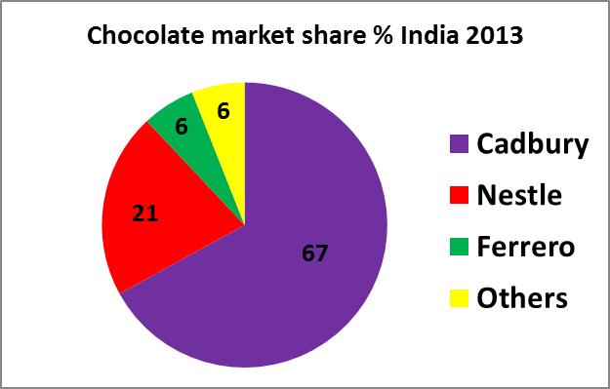 | The market for chocolate in India has a value of just £555m at the moment. It is this small because Indians currently eat less than a sixtieth of the amount of chocolate eaten in Britain (0.165kg a year compared with our 10.2 kilogrammes!). But the market is forecast by Cadbury to grow at 23% a year between 2013 and 2018, which will take it towards the U.K.’s market size.
Mr Natarajan’s marketing strategy has two further elements to it. There is a marketing plan targeting the 0-18 age category, based on free distribution of sweets twice a year, on Independence Day and again on Republic Day. 19-35s will also be targeted using a tie-up with Facebook. One week before, Facebook will send the message ‘Do you want to send chocolates on your friend’s birthday?’ There can be no doubt that Mars is determined to succeed.
Questions (25 marks; 30 minutes)
1. Explain two possible reasons why Mars wants to build a market share in India. (4)
2. Outline one possible barrier to entry to Mars in its attempt to gain market share. (3)
3. Examine any conflicts in this new product launch between socially responsible and ethical behaviour and profit-based objectives. (9)
4. Discuss whether the pricing strategy for Galaxy is likely to prove successful for Mars. (9)
Marking Advice: Galaxy in India

1. Explain two possible reasons why Mars wants to build a market share in India. (4)
- In a fight for the $100bn global market for chocolate, India’s 1.2bn people must surely matter in the long run; so Mars has to try hard to break into this market
- If India really is the fastest growing chocolate market in the world, Mars would naturally see profitable opportunities for many products within its brand portfolio, eg Galaxy, Bounty and Malteasers

2. Outline one possible barrier to entry to Mars in its attempt to gain market share. (3)
- Cadbury’s 67% market share must look very daunting; this strength will translate into powerful positions in-store, with high distribution and excellent display; Mars has to break through this to get retailers to stock its product range

3. Examine any conflicts in this new product launch between socially responsible and ethical behaviour and profit-based objectives. (9)
- The targeting of children as young as 0 (!) by giving away free samples seems questionable ethically; partly, of course, because it could be said to encourage children to eat sweets that may end up causing diabetes; but also because of the potential for ‘pester power’ to lead to poor families redirecting their spending from low cost, high nutrient raw materials such as flour to high cost, low nutrient processed foods; this seems a blatant trade-off between ethics and profit in which the latter wins hands-down

- Some people may feel that low pricing is itself unethical, given the opportunity it provides for younger children to try something they might otherwise not afford; this would only be a valid criticism if the Mars marketeers were consciously trying to scoop up people who would otherwise be outside the market; this seems unlikely; certainly there is no evidence provided to support that view

4. Discuss whether the pricing strategy for Galaxy is likely to prove successful for Mars. (9)
- Mars is using a strategy known as ‘market penetration’; this means trying to maximise market share by setting a price low enough to encourage high rates of product trial and high rates of repeat purchase; clearly it feels it has to invest heavily in this launch to give it a chance of success; no-one would doubt that low prices will be attractive to Indian consumers and therefore it should work in boosting trial; the problem with low-pricing is that it often creates dependency, i.e. makes customers expect continuing low prices, which may make it very difficult to achieve a profit

- Clearly Mars has no interest in short-term-only success in India. The goal is to make long-term inroads into Cadbury’s market share; by introducing Galaxy at a low price it might make it harder for the brand to establish itself as a match for the quality of Cadbury’s; perhaps Mr Natarajan is in too much of a hurry; better, perhaps, to use advertising and promotions to build sales solidly than low prices to achieve short-term sales at the cost of long-term image

