Getting Started in Business – the Cronut Craze
It’s 5AM, Soho, Manhattan and dozens of people are already in line. Only 3 hours until the Dominique Ansel bakery opens. Are they looking for work? No, they’re queuing for New York’s food craze of 2013: the cronut. And when the shop opens they’ll happily hand over $10 for a box containing just two of the pastries. It is said that they can be resold at 10 times the retail price, but as each customer is allowed just one box, this would be a hard way to make a living.
The cronut craze started in mid-May 2013 when bloggers spread the word about this new combination of donut and croissant at this new bakery. Baker-proprietor Ansel makes the flaky layers of a croissant into a ring shape, deep-fries it, then inserts patisserie cream and tops it off with a swirl of icing. Only 200 are made each day, so they sell out by just after 9.00 each morning. Ansel is trying to find a way to manufacture the cronut to meet demand throughout America. Until he does, the queues will persist. | 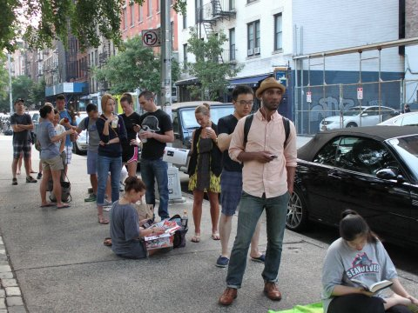
Remarkably Ansel has been allowed to trademark the name ‘cronut’, so although he has many imitators already, the ‘doissant’, the ‘zonut’ and the ‘dosant’ have not been able to convince customers that they are the real thing. This has helped him keep the price at more than double the typical price for a New York pastry.
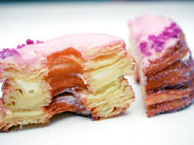 | But are the cronuts any good? College students Danielle Owens and Camara Lewis clearly think so, as they’ve succeeded 6 times in queueing and eating the cakes. Each month Dominique Ansel changes the flavour of the pastry crème filling, to encourage repeat purchase. The Financial Times reports that ‘The deeply buttery pastry is wonderful, crispy and stacked high with greedy, messy-to-eat layers; the lemon-maple cream is pleasingly sickly’. Visitors from around the US make a beeline for the bakery
Ansel has made a brilliant start so far to his business career. But can he turn the cronut into a nationwide success?
Questions (25 marks; 30 minutes)
1. Outline two entrepreneurial characteristics shown by Ansel in starting up his bakery. (4)
2. Explain the benefits to the Dominique Ansel Bakery of trademarking the cronut name. (5)
3. Analyse whether Dominique Ansel has spotted a gap in the market or developed an innovative product or process. (6)
4. Discuss three factors that may determine whether Ansel succeeds in developing a profitable business nationally. Explain which you think is the most important, and why. (10)
Marking Scheme (25 marks)

1. Outline two entrepreneurial characteristics shown by Ansel in starting up his bakery. (4)
Marking scheme: up to 2 for relevant points; up to 2 for application
- Flair for understanding the need to stand out from the crowd – the competition; this led him to the cronut (which is generating $1,000 a day in revenue)
- Showing understanding that it’s not enough to sell once to customers – repeat purchase is critical to long-term success; changing the flavour each month makes it worthwhile for fans to return

2. Explain the benefits to the Dominique Ansel Bakery of trademarking the cronut name. (5)
Marking scheme: up to 2 for relevant knowledge; up to 2 for application; up to 1 for analysis
- The trademark stops others being able to call their pastries a ‘cronut’; this helps remove some direct competition, which may make it easier to charge quite high prices
- It also ensures that no inferior, rival ‘cronuts’ can damage Ansel’s good name – which can give him the confidence to try to build his business from New York to the whole country

3. Analyse whether Dominique Ansel has spotted a gap in the market or developed an innovative product or process. (6)
Marking scheme: up to 2 for relevant knowledge; up to 2 for application; up to 2 for analysis
- In a sense he’s found a product gap in the market space between a doughnut and a croissant; but given that there are a lot of cakes out there, it’s not clear that this is a real gap (in the way that smoothie makers found a real gap between juice and ice cream)
- ... but it seems much more significant that he has brought out an innovative product (the text gives no hint of an innovative process of manufacture); it is the novelty of the product that is bringing queues (plus, perhaps, his cleverness in keeping production levels low enough to create a queue and a whole host of publicity

4. Discuss three factors that may determine whether Ansel succeeds in developing a profitable business nationally. Explain which you think is the most important, and why. (10)
Marking scheme: up to 2 for relevant knowledge; up to 2 for application; up to 2 for analysis; up to 4 for evaluation
- The text mentions that US visitors to New York rush to Ansel’s, so it may be that a significant amount of pent-up demand is being generated. If so, a national launch might get off to a great start; this should overcome a major hurdle to many new launches: a failure to get good retail distribution; if Ansel can keep up the publicity that’s associated with the queues, he should get off to a good start
- Speed is inevitably an issue; by definition a ‘craze’ comes to an end; so it’s vital that any move to a national presence should happen soon, while people are still interested in Cronuts; given that Ansel’s bakery probably has only one manager (Ansel), it may be extremely difficult to make and implement the plans needed for national success
- The text tells us nothing about the finances of Ansel’s Bakery; however profitable the business is proving, the cost of a national launch (building a factory, spending on TV advertising etc) would be colossal – almost certainly way out of Ansel’s league. Is he willing to accept outside investment, perhaps from a venture capital business? If not, the rapid growth may lead to a cash flow implosion

Without question, ignoring the financial threats involved in rapid expansion would guarantee failure, so these must be addressed with care; almost certainly Ansel must be willing to sell a stake in the business; the market-based factors are hugely important, but running out of cash would be the single worst outcome

