Starting Sumo
In November 2011 entrepreneur Richard Baister launched ‘Sumo’ drinks – claimed to be the world’s first calorie-burning soft drink. With no carbs and 2.5 calories, the ‘fruit flavoured soft drink contains functional ingredients which increase the metabolic rate and help the body to burn calories more quickly’. In two flavours (Tropical and Summer Fruits) and with this amazing USP, what could go wrong?
Baister certainly started well. He had spent three years perfecting the drink, and nearly as long getting finance into place. Sumo benefited from two rounds of investment from Northstar Ventures, who manage funds on behalf of the European Investment Bank. The EU saw two qualities in this investment: first, it could help with the anti-obesity agenda and second it was an investment into a business starting up in the North-East of England. | 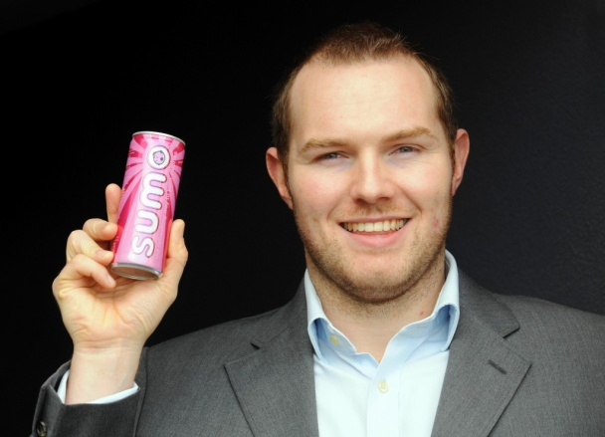

So what was Baister’s background? After various money-making schemes at school and university, at 24 Baister decided to start his own business based upon the trend towards healthier lifestyles. Cleverly, he noticed that the emergence of ‘functional’ food and drinks (good for you, e.g. ‘healthy bacteria’) opened up new opportunities that might be hard for large, inflexible firms such as Heinz. He started Velocity Drinks in 2005 and sold the business in 2008 for an undisclosed sum.
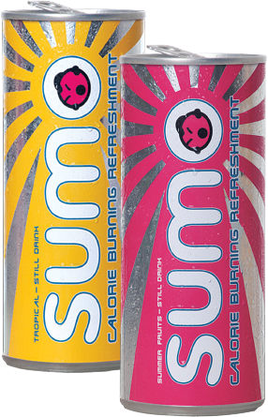 | With his background experience, Baister was able to achieve quite a lot of publicity when he launched. And was later to win awards for entrepreneurship. He was able to boast of a secure distribution deal in Ireland and many sales prospects worldwide. Yet, quite simply, the business has never taken off in Britain; nor is there evidence of profitable sales overseas.  Baister had experience, financial backing and an apparently marvellous product idea.  What might have gone wrong?

Questions (30 marks; 30 minutes)
1. Sumo’s long-term finance was provided by Northstar Ventures. Explain how a bank overdraft may also have been useful to the company. (5)
2. Explain the role of an entrepreneur such as Richard Baister in the start of a business such as Sumo. (5)
3. Based upon the text and your wider understanding of new businesses, discuss what probably went wrong with the Sumo start-up. (10)
4. One problem may have been the price set for the product. Discuss how Baister might have used market research to decide on the right retail price per can. (10)
Marking Advice
1. Sumo’s long-term finance was provided by Northstar Ventures. Explain how a bank overdraft may also have been useful to the company. (5)
Knowledge: up to 2 marks: short-term finance; high daily interest charges; useful for daily fluctuations in cash flow;
Application: up to 3 marks: cash flow often negative at the start of a new business; to fulfil the Irish order would require a big cash investment, so might need an overdraft until payment is received

2. Explain the role of an entrepreneur such as Richard Baister in the start of a business such as Sumo. (5)
Knowledge: up to 2 marks: the entrepreneur needs analytic and creative qualities but – above all – must have the persistence and energy to make things happen; turn an idea into a business
Application: up to 3 marks: Baister was able to analyse the market for functional soft drinks and spot the opportunity for innovation; he was also able to negotiate successfully for external finance; he needed to be – and was – not just the brains but also the personality at the heart of the business

3. Based upon the text and your wider understanding of new businesses, discuss what probably went wrong with the Sumo start-up. (10)
Marking scheme: up to 2 for relevant knowledge; up to 2 for application; up to 2 for analysis; up to 4 for evaluation
Possible answers include:
- Frankly, the can design is a worry; it is hard to see it as a convincing package for an apparently serious new product idea; the colours (and can itself) shout fun and froth, not an aid to slimming and health; fundamental to the marketing of Sumo was consumer credibility and confidence (i.e. do you believe the claim?); the can would not have helped
- In a similar way, it’s hard to see what ‘Sumo’ has to do with the proposition; what have fat Japanese got to do with weight loss? Sumo wrestlers want to be that big! For both these reasons, the marketing seems very muddled
- Even if the marketing messages had been appropriate, the business would still stand or fall on getting distribution from the big retailers. The text gives no indication of selling in to any supermarket, or indeed any other outlets in Britain; perhaps Richard Baister, for all his good qualities, was no salesman
- Finally, there may have been financial issues. Perhaps the external funding was never quite enough to allow the business to promote itself – to hire sales teams or to run TV advertising
Main lines of evaluation:
- Starting a business is so complicated that there a huge number of possible explanations for failure; the ones identified stem logically from the evidence, but the real reason may be something completely different, e.g. disappointing taste (and therefore low repeat purchase)
- Of course it may be that the implementation was OK, but the underlying business logic was faulty; perhaps consumers would believe in a calorie-busting drink – but only if it comes from a big, trusted name such as Coca-Cola

4. One problem may have been the price set for the product. Discuss how Baister might have used market research to decide on the right retail price per can. (10)
Marking scheme: up to 2 for relevant knowledge; up to 2 for application; up to 2 for analysis; up to 4 for evaluation
Possible answers:
- Realistically, his budget for market research would have been tiny, but ideally he would have researched carefully every element of the Sumo proposition: the name, the type of packaging, the branding, logo and pack colour and, of course, the price; note that these are intertwined, i.e. the right price would depend in part on the type of packaging; if (as in this case) the packaging looks cheap, surely the price would have to follow
- A research starting point could have been qualitative, e.g. group discussions/focus groups; if Baister could have got an independent market research company to track down a representative sample of young, weight-focused individuals, he might have conducted the focus groups himself to save money ...
- ... from this he would have found out what people would be prepared to pay for a calorie-killing drink (surely, quite a lot); certainly he would have learnt some of the psychological underpinnings of this product idea, e.g. the level of scepticism about the claim (which might have led him to run free taste-sessions in supermarkets as a way of achieving product trial)
- After learning from the qualitative research, a quantitative study would have been ideal, to get statistically valid findings to show, perhaps, the likely sales volume at £1 a can compared with £1.50 or £2. That would have helped him make a final pricing decision
Possible lines of evaluation:
- In this case, the pricing decision would have been exceptionally linked to decisions about pack design and image; given the pack shown in the article, it is to be hoped that Baister ended up choosing quite a low pricing point
- Market research can only be as accurate as sample sizes allow, and therefore budgets allow; in the case of a brand new business it’s likely that any market research would have been done on a shoestring – perhaps undermining its reliability and validity

